# Install mysql server

$ sudo apt-get update

$ sudo apt-get install mysql-server

# Check version

$ mysql –version

mysql Ver 14.14 Distrib 5.7.30, for Linux (x86_64) using EditLine wrapper

# Verify Installation

$ sudo systemctl status mysql.service

# Start mysql

$ sudo systemctl start mysql.service

Status must be Active(Running)

# Configuring

$ sudo mysql_secure_installation

Set password

Remove anonymous user – Y

Disallow root access remotely – Y

Remove test database – Y

All done!

# Configure mysql Shell

$ sudo mysql

Check authentication method for users

Mysql> SELECT user,authentication_string,plugin,host FROM mysql.user

mysql> SELECT user,authentication_string,plugin,host FROM mysql.user;

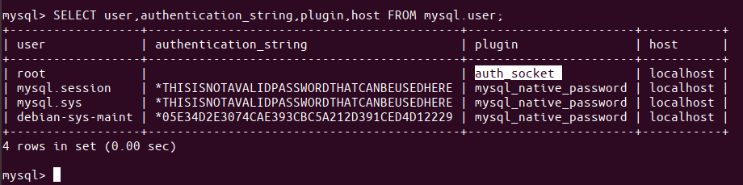

In the above output, you can see that root is using the auth-socket plugin for authentication by default.

### Step 3: Change the authentication method for root

Our purpose here is that the root user should authenticate with a password on MySQL. To do this, run the following command that lets the root be identified by a mysql_native_password. Please remember that this password has to be very strong.

mysql> ALTER USER 'root'@'localhost' IDENTIFIED WITH mysql_native_password BY 'password';

<img class="aligncenter wp-image-4295" src="https://vitux.com/wp-content/uploads/2019/03/word-image-132.png" alt="Change authentication method for the root user" width="824" height="77" srcset="https://vitux.com/wp-content/uploads/2019/03/word-image-132.png 824w, https://vitux.com/wp-content/uploads/2019/03/word-image-132-300x28.png 300w, https://vitux.com/wp-content/uploads/2019/03/word-image-132-768x72.png 768w" sizes="(max-width: 824px) 100vw, 824px" />

From now on your root will not have the password you specified while running the included security script, but this strong password you specified in the above-mentioned command.

### Step 4: Reload grant tables

Now is the time to tell the server to use the new privilege settings from now on. Run the following command in the MySQL prompt to reload the grant tables and register your changes:

mysql> FLUSH PRIVILEGES;

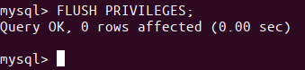<img class="aligncenter wp-image-4296" src="https://vitux.com/wp-content/uploads/2019/03/word-image-133.png" alt="Reload Grant tables" width="339" height="78" srcset="https://vitux.com/wp-content/uploads/2019/03/word-image-133.png 339w, https://vitux.com/wp-content/uploads/2019/03/word-image-133-300x69.png 300w" sizes="(max-width: 339px) 100vw, 339px" />

### Step 5: Recheck authentication method for MySQL users

Now, when you recheck the authentication method for your MySQL user accounts through the following command, you will see that your root user is now using the mysql_native_password plugin for authentication:

mysql> SELECT user,authentication_string,plugin,host FROM mysql.user;

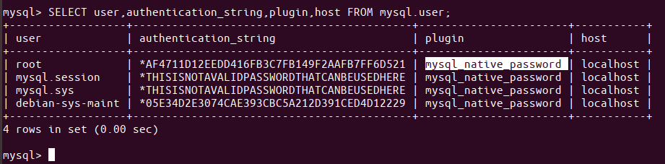<img class="aligncenter wp-image-4297" src="https://vitux.com/wp-content/uploads/2019/03/word-image-134.png" alt="Re-check authentication method" width="921" height="227" srcset="https://vitux.com/wp-content/uploads/2019/03/word-image-134.png 921w, https://vitux.com/wp-content/uploads/2019/03/word-image-134-300x74.png 300w, https://vitux.com/wp-content/uploads/2019/03/word-image-134-768x189.png 768w" sizes="(max-width: 921px) 100vw, 921px" />

Now that your root user is setup to connect to the MySQL shell through a secure password, you can exit the shell using the exit command as follows:

mysql> exit

## Test if MySQL is Up and Running

In order to check if MySQL is running on your system or not, you can use one of the following methods:

### Method 1: Check the status of mysql.service

After you have installed MySQL on your system, the mysql.service should most probably be automatically running. The output of the following command should verify the active status of the service:

$ systemctl status mysql.service

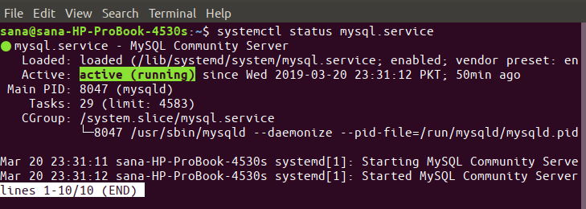<img class="aligncenter wp-image-4298" src="https://vitux.com/wp-content/uploads/2019/03/word-image-135.png" alt="Check MySQL service status" width="729" height="260" srcset="https://vitux.com/wp-content/uploads/2019/03/word-image-135.png 729w, https://vitux.com/wp-content/uploads/2019/03/word-image-135-300x107.png 300w" sizes="(max-width: 729px) 100vw, 729px" />

If for any reason, the service is not running you can use the following command as sudo to start the service:

$ sudo systemctl start mysql

The following command will help you in stopping the service whenever you have to:

$ sudo systemctl stop mysql

### Method 2: By connecting to MySQL Admin as root and running any administrative command

MySQL Admin is a client that lets you perform administrative operations on MySQL. Let us run one of the administrative commands through it as an example to check if the system is running properly and our root is configured to use it.

$ sudo mysqladmin -p -u root version

This command is meant to connect to MySQL as root, prompt for root password and then return the version number of MySQL admin.

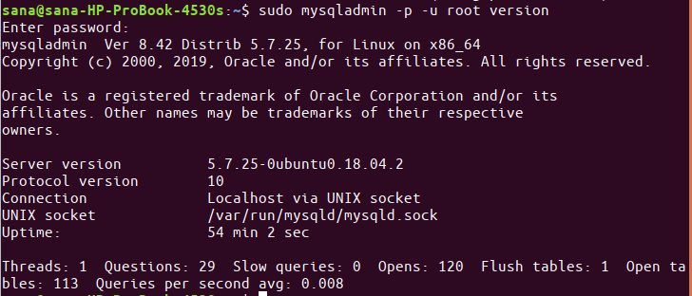

If the command does what it is required to and produces output similar to the above one, you can be sure that your MySQL is up and running.

The process of installing and setting up MySQL on Ubuntu might seem cumbersome to some, especially using the command line. If you, however, use the above mentioned steps carefully one by one, you will have no problem in having a reliable, secure and stable installation of MySQL running on your Ubuntu.

# Connect MYSQL from remote

Go to /etc/mysql/mysql.conf.d/mysqld.cnf

Change bind-address = 0.0.0.0

Comment skip-networking (#skip-networking)

Restart mysql - sudo systemctl restart mysql

Set firewall to access port 3306 only from selected IPs – sudo ufw allow from 85.148.189.6 to any port 3306

Set user to access DB only from selected IPs-

Mysql> GRANT ALL ON dequizdb.* TO ‘mdubeydev’@’85.148.189.6’ IDENTIFIED BY ‘Manish123$’;

Mysql> FLUSH PRIVILEGES;